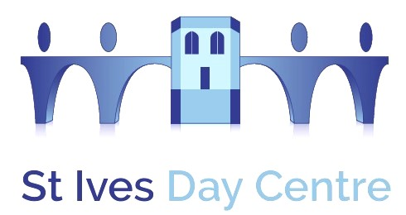

St Ives Day Centre is here to help those who may be frail and elderly within our community to maintain their independence and get the most out of life. We provide the opportunity to meet others socially, to engage in a range of activities, share a hot lunch and enjoy our afternoon entertainment. To maintain our level of service and provide a caring, safe environment for anyone who is isolated or lonely with or without mental and/or physical needs, we rely on our lovely volunteers who help members to and from the bus, serve refreshments, chatting, assisting them to take part in activities such as bingo, and helping to serve lunch and clear away afterwards.
We are open from 0930 – 1530 Monday to Friday but can be flexible to work around you. If you would like any further details about joining our friendly team, please get in touch on 01480 463444, daycentre25@googlemail.com or drop in to see us

